Supplemental materials
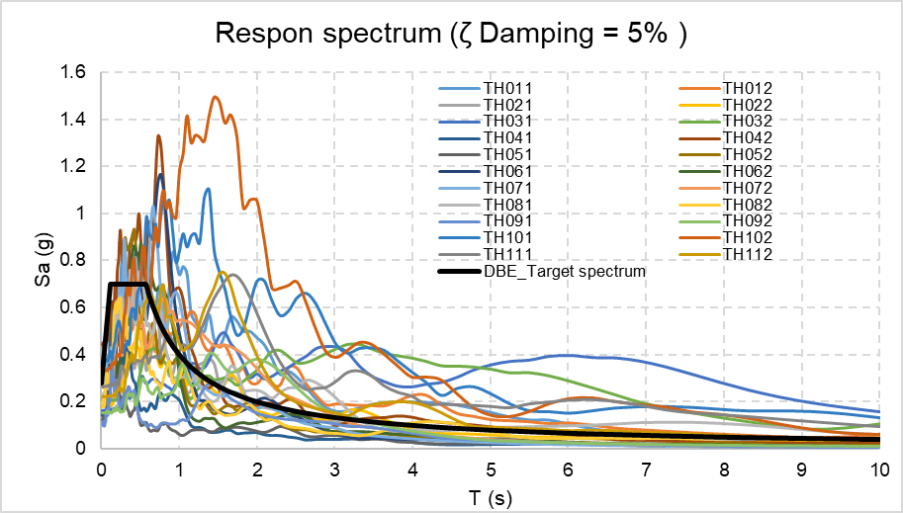
Fig. S1. Spectral matching between the sets of ground motion records selected for nonlinear analyses
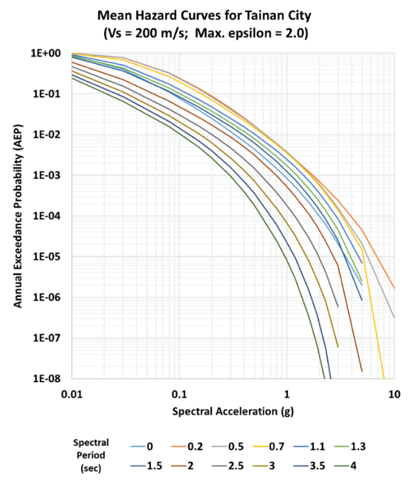
Fig. S2. Mean hazard curves for Tainan City

Table S1. Weather data uncertainty parameters
category |  | Dry Bulb Temperature | Relative Humidity | Global Horizontal Radiation | Wind Speed
category |  | Lognormal | Normal | Lognormal | Weibull
category |  | [°C] | [%] | [Wh/m²] | [m/s]
Tainan TMY | Mean | 24.440 | 77.680 | 195.950 | 3.290
Tainan TMY | Std | 5.130 | 10.580 | 166.050 | 1.550
SSP126_2050 | Mean | 25.640 | 77.350 | 203.480 | 3.290
SSP126_2050 | Std | 5.090 | 10.350 | 275.960 | 1.550
SSP245_2050 | Mean | 25.810 | 77.520 | 199.690 | 3.270
SSP245_2050 | Std | 5.090 | 10.310 | 270.880 | 1.540
SSP370_2050 | Mean | 25.980 | 77.680 | 194.490 | 3.250
SSP370_2050 | Std | 5.120 | 10.310 | 263.920 | 1.530
SSP585_2050 | Mean | 26.250 | 77.440 | 200.250 | 3.270
SSP585_2050 | Std | 5.090 | 10.230 | 271.640 | 1.540

Table S2. Building energy input uncertainties (Wang et al. 2025)
Uncertain | Unit | Distribution | Uncertain inputs
Roof U-value | W/(m2⋅K) | Discrete uniform | 0.500/0.450/0.380/0.350
Wall U-value | W/(m2⋅K) | Discrete uniform | 0.800/0.670/0.570/0.500
Window U-value | W/(m2⋅K) | Discrete uniform | 2.700/2.300/1.900/1.500
Shading | SC | Discrete uniform | 0.550/0.500/0.450/0.400
Photovoltaic efficiency | ηPV | Uniform | - %-21.4 %

Table S3. Probabilistic Input Parameters for Life Cycle Assessment (LCA)
 | Variable | unit | Distribution | Mean (ln) | Std Dev (ln)
Material & Equipment Costs (Public Construction Commission 2026; Taiwan Power 2024)
 | Ready-mixed concrete price | USD/m³ | Lognormal | 4.586 | 0.043
 | Steel bar for reinforced concrete | USD/kg | Lognormal | -0.340 | 0.050
 | Connection/anchor price | USD/unit | Lognormal | 0.116 | 0.090
 | PV panel | USD/pcs | Lognormal | 3.874 | 1.250
 | Inverter price | USD/unit | Lognormal | 6.687 | 1.350
 | PV wiring / labor (energy) | USD/m² | Lognormal | 2.776 | 1.100
 | Electricity price | USD/kWh | Lognormal | -1.355 | 0.050
Labor & Operation Costs (Public Construction Commission 2026)
 | General labor | USD/hr | Lognormal | 4.240 | 0.142
 | Concrete technician | USD/work | Lognormal | 4.406 | 0.097
 | Vibrator operation | USD/work | Lognormal | 2.498 | 0.076
 | Scaffold cost | USD/work | Lognormal | 2.417 | 0.204
 | Steel labor | USD/hr | Lognormal | 2.537 | 0.203
Embodied / Operational Emission Factors (Climate Change 2026; Taiwan Climate Action 2026)
 | Concrete EF | kgCO₂/m³ | Lognormal | 5.561 | 1.160
 | Steel EF | kgCO₂/kg | Lognormal | -0.116 | 1.800
 | PV panel EF | kgCO₂/m² | Lognormal | 4.306 | 1.200
 | Electricity grid EF | kgCO₂/kWh | Lognormal | -0.766 | 0.149

References:
Climate Change, A. 2026. Carbon Footprint Emission Factors. Ministry of Environment Open Data Platform.
Public Construction Commission, E. Y. 2026. “Public Construction Price Database (PCIC) - Construction Cost Query System.” Public Construction Commission, Executive Yuan.
Taiwan Climate Action, N. 2026. “Taiwan’s electricity emission factor over the past decade [Data set].” Taiwan Climate Action Network.
Taiwan Power, C. 2024. “Taiwan Power Company Rate Schedules.” Taiwan Power Company.
Wang, W., L. Zhu, J. Zhang, X. Zhu, Z. Yan, and M. Cao. 2025. “Evaluation of energy retrofits for existing office buildings through uncertainty and sensitivity Analyses: A case study of Tianjin, China.” Energy and Buildings, 331: 115363.

